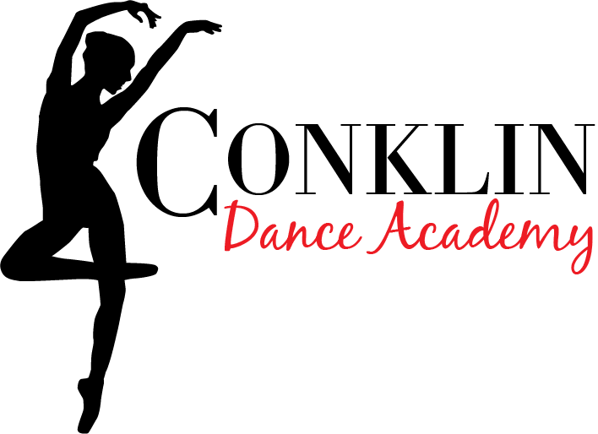
Studio Policies & Information Packet
2024-2025 Season
WELCOME!
On behalf of the Conklin Dance Academy, we wish to extend a warm and sincere welcome to our studio for our 13th Year! Please take a moment to familiarize yourself with our studio policies. Please know that our policies are intended to ensure that each student receives our utmost attention and is given every opportunity to reach his or her full potential. Classes begin Monday, September 9, 2024.
- Registration
On behalf of the Conklin Dance Academy, we wish to extend a warm and sincere welcome to our studio for our 13th Year! Please take a moment to familiarize yourself with our studio policies. Please know that our policies are intended to ensure that each student receives our utmost attention and is given every opportunity to reach his or her full potential. Classes begin Monday, September 9th 2024.
- Class Tuition
All class lessons are paid monthly, by the 5th of each month. Pay online or at the desk in the lobby. Prices:
30 min Class: $45.50 Per month
45min Class: $52.50 Per month
1 hour class: $57.50 Per month
1.5 hour class: $72.50 per month
Unlimited classes (5+ hrs per week): $230 per month
Private Lessons (30min/week): $80 per month
Duo/Trio Lesson (30min/week): $50 per month (per student)
​
- There are no refunds given for terminations during the season.
• Tuition is separated into 9 equal payments, September- May and based on 4 classes a month. Tuition is the same each month, regardless of holiday closures. Auto pay is available! • To pay your tuition, you will need to log on to: https://app.thestudiodirector.com/conklindanceacademy/portal.sd
**Auto pays will be processed on the 1st of each month, starting in September and ending in May
- There is a $15 late charge per class for tuition paid after the 5th of each month. If your account goes unpaid for 6 weeks, your child will be withheld from participating in class until the balance in paid.
There is a charge of $30.00 for all returned checks.
- There are no refunds for classes missed because of one’s personal vacations, illnesses, or terminations during the month.
- If there are more than two cancelled classes in a month, a makeup class will be scheduled.
Auto-pay accounts will be processed on the 1st of each month. If your child discontinues lessons, you must notify us to cancel your auto pay. Otherwise, you will continue to be charged.
- NO REFUNDS WILL BE GIVEN FOR ANY REASON. If you discontinue lessons at any time, you are still responsible for payments prior to communicated (in person, email or text) drop date.

- Tuition Specials
- All boys tuition is 50% off!
- 10% off tuition if the year is paid in full prior to August 30th. Private lessons and costumes are not included.
- Classes paid using these special and are cancelled during the year will be charged a processing fee of 10%. - -Payment must be made by the due date to receive the percentage off your total.
*Please note: Boys tuition discount cannot be combined with any other discount, including full year and half year payments

- Shoes & Attire
All shoes for ‘noncompetitive’ classes are to be ordered through the Studio online shop. This will assure a ‘uniform’ look, which is necessary for our Annual Recital.. Hair must be pulled back in either a ‘pony tail’, braid, or ‘bun’ in all classes; and please, no large jewelry or gum chewing. For all Ballet classes, hair must be secured in a bun. Use this link to order shoes and apparel: www.shopnimbly.com/CDA1299

- Studio Closures & Cancellations
When weather is threatening, please call the studio @ 607.301.3039 and a recorded message will confirm all Studio closures due to ‘bad weather’. Please also consult the Studio Website and Facebook. A message confirming all ‘weather related’ Studio closures will be posted both on the ‘home page’ and on the cell phone voicemail by 2pm.
Studio Closures/Holidays
• Columbus Day-Oct 14th
• Thanksgiving – November 27-29th
• Christmas - December 23-January 2nd.
• Winter Recess- February 17th
• Spring Recess: April 18th-25th
• Memorial Day - May 26th
- Reception Room
The Reception Room is available to parents while students are attending class. Young children must always be under the supervision of a responsible adult. We ask that you keep the noise level at a minimum so to not interrupt classes. Children are allowed to play on the property, which adjoins the Studio. Please be EXTRA Cautious when eating or drinking in the lobby area. If you spill, please clean it up! Please do not adjust the ‘dance room TVs’ or window blinds. Lastly, thank you for not smoking in the studio and surrounding property. We kindly ask that you refrain from entering the dance rooms while classes are in session, unless it is an emergency.

- Recital Costumes & Picture Day
A recital costume(s) will be required for each student & routine. A $45.00 costume deposit (for each costume ordered) is due no later than October 20th, with the balance due NO LATER than December 1st, 2023. Costume deposits are non-refundable. The balance is usually no more than an additional $45 for non-competitive classes. Your costume payment includes one pair of recital tights, as well as shipping and handling. Once the costume order is placed, NO REFUNDS CAN BE GIVEN. We expect all costumes to arrive at the studio late March and early April. We will hold our Picture Day at the studio during the month of May, date TBA.
MALE STUDENTS: PLEASE ONLY MAKE THE DEPOSIT FOR YOUR CHILD’S COSTUME. WE WILL TOUCH BASE IF MORE IS NEEDED.

- Annual Recital
We are excited to announce that this year’s Recital will be held once again at the Forum Theatre in Downtown Binghamton in early June. Recital Rehearsal will be held on the week before the recital at the theater. Recital tickets will go on sale in Late April/Early May 2023.

I, ______________________________, parent/guardian of student

_______________________________ agree to the policies listed above and understand my responsibility as the dance parent.

Date: Signature:

Direct Deposit Agreement
By signing up for Direct Deposit, you agree to all monthly tuition charges being deducted from your account on the first of each month. Costume fees will need to be paid by check or cash at the studio. If your payment is rejected, you will be charged a fee of $10. If you are to discontinue lessons, you must notify us to delete your auto pay. If you do not notify us, you will continue to be charged fees at no fault of us.

CC#

Exp:

Account holder:

Signature & Date:

Items needed for your child’s class
All items can be ordered using this link: WWW.SHOPNIMBLY.COM/CDA1299
Log in and locate your child’s class to purchase your items. All items are shipped directly to you.
Preschool Ballet/Tap (Mon 5 or Wed 530):
- Stretch ballet shoe in classic pink color
- Easy on student tap shoe in Dark Tan Color
- Leotard & Tights or dance dress any color or style

Tutu 1- Tuesday 430-515
- Stretch Ballet Shoe is classic pink color
- Skirted Leotard in Pink color
- Full foot or Convertible tights in Classic Pink

Ballet & Tap Combo I Mondays & Combo II Thursdays
- Stretch ballet shoe in Classic pink color
- U-shell Tap shoe in Dark Tan
- Leotard and tights, or dance dress in any color/style

TuTu 2
-Stretch Ballet shoe in classic pink color
- Seamless short sleeve leotard in Lavender color
-Full foot or convertible tight in Classic pink color

Jazz/Hip Hop Monday 515pm

- Tank top or tshirt
- Yoga pants or shorts
- Sparkle high top sneaker

Beg/Intermediate Tap Monday

- Ushell Tap shoe in Dark Tan
- Leotard and shorts or yoga pants, any color.

Teen Tap
- Jazz Tap shoe in Dark Tan
- Leotard and shorts or yoga pants, any color.

Teen Jazz

- Stretch slip on jazz shoe in dark tan color
- Leotard and tights, or yoga pants/shorts any color

Teen Ballet/Lyrical

- Canvas half sole in Nude
- Leotard and tights any color
- No tshirts or street clothing

All Acro Classes

- Leotard and shorts/yoga shorts any color
- No tshirts, or street clothing

TuTu 3

- Classic pinch front leo in Teal color
- Full foot or convertible tight in classic pink
- Stretch ballet shoe in classic pink color
- Other petite classes, leotard and tights any color, class shoes- stretch jazz boot in dark tan, Jazz tap shoe in dark tan

TuTu 4
- Black leotard, pink tights, pink ballet shoes
- Other classes- sports bra, yoga shorts, leotard and shorts, turning shoe & capezio tap shoe

